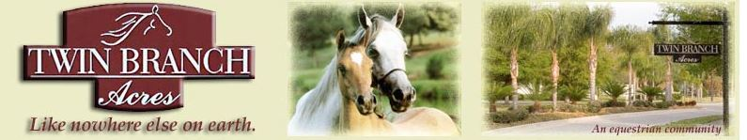

TBA 2017 Year in Review

- Continuing
- Dues payment-Invoices mailed & emailed. Maintaining at 65%.
- Front entrance plantings, maintenance & mulching
- Community Yard Sales (2 per year)
- Horse trail clean up & bush hog front field & drainage easements
- Winter Fest & Golf Cart Parade
- Welcome Committee & Baskets
- Holiday Card mailing
- Neighborhood Watch
- Working with county on Flood Control
- Messages on front board, text service and FB communications & administration
- Sidewalk edging
- Maintained LED lighting system at entrance landscaped area
- Installed and maintained LED lighting systems for our two pond fountains
- Picked up trash at entrance area on a weekly basis
- Accomplishments in 2017
- Hired new landscape contractor
- Trimmed bamboo hedge along Racetrack Road
- Trimmed overhanging tree branches at entrance which were interfering with taller vehicles
- Cut down dead Pine tree on north vacant lot
- Maintained Clear Equestrian Easement thru legal efforts.
- Attended / Discussed with County several meetings concerning Drainage / Storm Water Run-off projects.
- Contacted county to initialize clean up at 2nd bridge to include removal of trees & low lying branches
- Replaced Irrigation timers / valves
- Secured quotes for Well / Security Cameras / Landscaping
- TBA Volunteers cleared Twin Branch Creek of large tree and vegetation debris after Hurricane

- Continued work on Unification for State requirements for Re-Instatement of Deed Restrictions
- On-line Payment for annual dues
- Installed QuickBooks financial tracking for TBA
- Added Joey, the small concrete horse statue, to our exit lane landscape
- Painted wall signs and cleared vegetation from north side of vacant lot
- Painted and decorated back side of Twin Branch Acres sign facing Horseshoe Road
- Contacted Hillsborough County for edging maintenance along Twin Branch Acres Road for full visibility of white stripes
- Improved holiday lighting and decoration display at entrance area
- Contacted TECO for repairs of inoperative street lights
- Reported an environmental violation for neighborhood cleaning the east branch of Double Branch Creek without a permit.
- Goals & Priorities in 2018
- Continued Increase membership/community involvement
- Support Committee Lead initiatives

